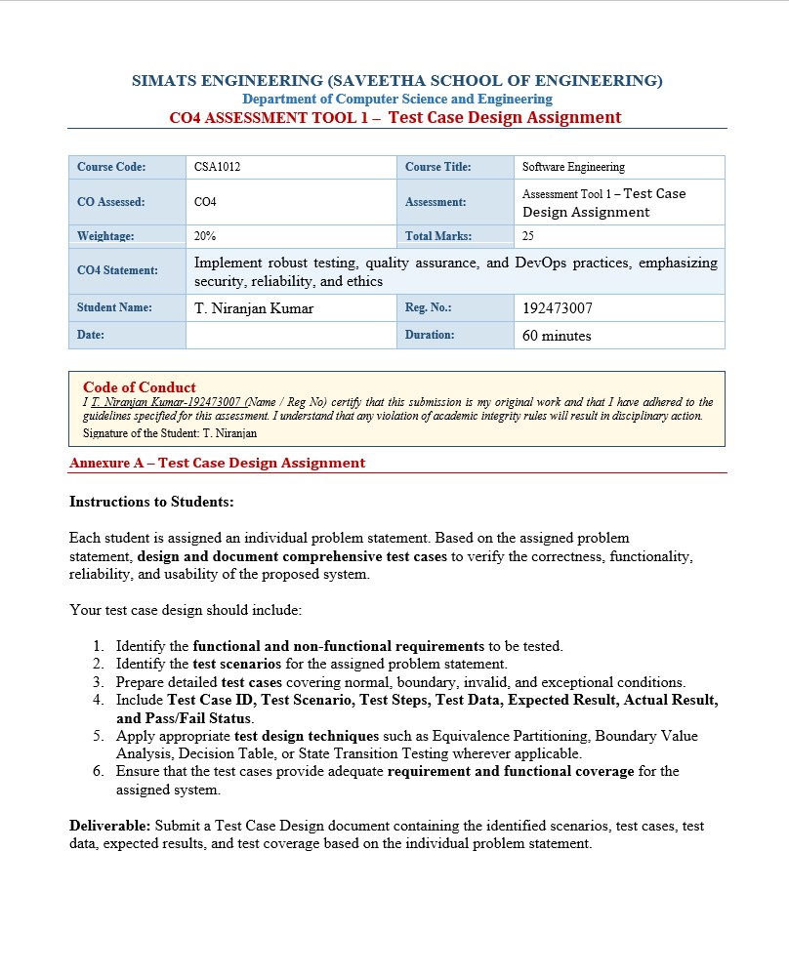

1. Problem Statement
Beginner developers often find it difficult to identify suitable open-source projects and issues because of the large number of repositories and different levels of complexity. The proposed system recommends beginner-friendly issues based on programming skills and interests, tracks contributions across repositories, visualizes skill progression, provides community insights, sends notifications, and generates a contribution portfolio.

2. Objectives
- Recommend beginner-friendly open-source issues using known programming languages and interests.
- Fetch and filter repositories/issues through GitHub API using labels such as “good first issue” and “help wanted”.
- Track pull requests, issue activity, and merge status across repositories.
- Visualize skill progression using contribution frequency, complexity, and technology diversity.
- Score project and issue difficulty for beginner suitability.
- Notify users about new matching beginner-friendly issues.
- Generate a portfolio summary of open-source contributions.
- Provide community insights including responsiveness, mentorship, and contributor-friendliness.

3. Functional Requirements
ID | Requirement
FR1 | User profile management
FR2 | Programming skills and interests
FR3 | Personalized issue recommendations
FR4 | GitHub API integration
FR5 | Beginner-friendly label filtering
FR6 | Contribution and PR tracking
FR7 | Contribution progress tracking
FR8 | Difficulty scoring
FR9 | Skill progression dashboard
FR10 | Notifications
FR11 | Portfolio generation
FR12 | Community insights

4. Non-Functional Requirements
ID | Requirement
NFR1 | Fast response for common user actions.
NFR2 | Secure handling of user information.
NFR3 | Reliable GitHub data retrieval.
NFR4 | Beginner-friendly and understandable interface.
NFR5 | Scalable handling of repositories and contribution history.
NFR6 | Graceful recovery from network/API failures.
NFR7 | Relevant and useful recommendations.
5. System Architecture
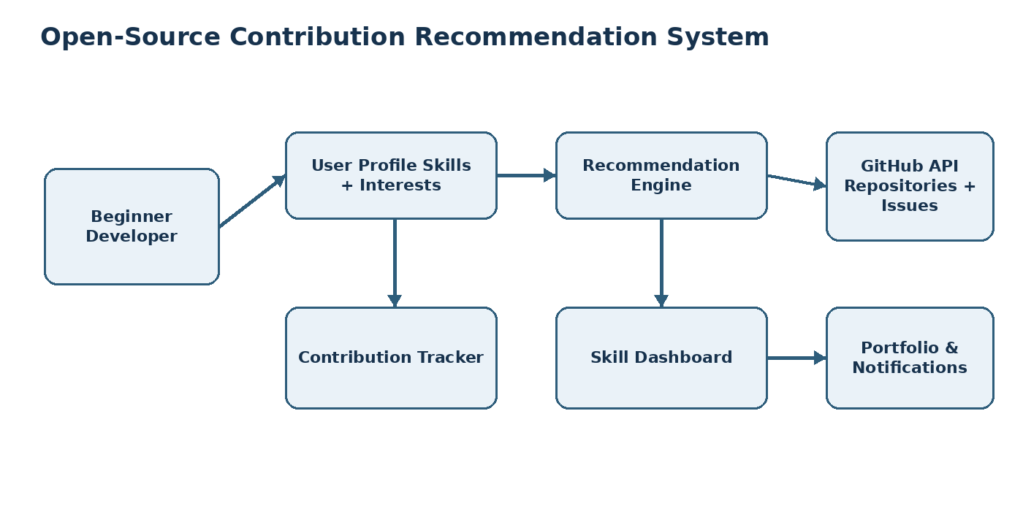
The architecture connects the beginner developer profile to the recommendation engine, GitHub data source, contribution tracker, dashboard, notifications, and portfolio generation modules.

6. Test Scenarios
Scenario ID | Test Scenario
TS01 | Create/update developer profile
TS02 | Enter programming skills
TS03 | Enter user interests
TS04 | Generate beginner-friendly recommendations
TS05 | Filter issues using beginner labels
TS06 | Handle GitHub API response
TS07 | Handle GitHub API failure
TS08 | Track pull request status
TS09 | Track issue contribution
TS10 | Calculate contribution progress
TS11 | Calculate project difficulty
TS12 | Display skill progression
TS13 | Send matching issue notification
TS14 | Generate contribution portfolio
TS15 | Display community insights
TS16 | Handle invalid/empty user data
TS17 | Handle large contribution history
TS18 | Protect user information

7. Test Case Design
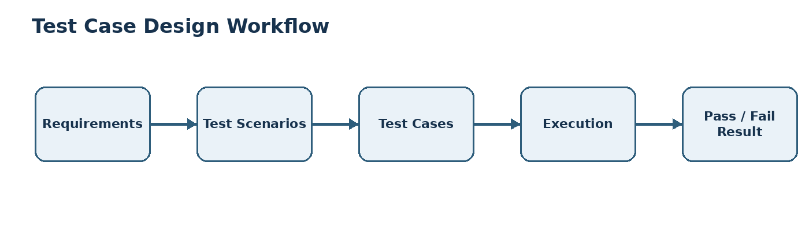
ID | Scenario | Test Steps | Test Data | Expected Result | Actual Result | Status
TC01 | Create profile | Open system → Enter profile details → Save | Name: Ravi; Level: Beginner | Profile should be created successfully. | Not Executed | Not Executed
TC02 | Empty profile | Leave mandatory fields empty → Save | Name: Empty | Validation message should be displayed. | Not Executed | Not Executed
TC03 | Add programming skill | Open Skills → Select language → Save | Python | Python should be added to profile. | Not Executed | Not Executed
TC04 | Multiple skills | Add multiple languages | Python, Java, C++ | All selected skills should be stored. | Not Executed | Not Executed
TC05 | Generate recommendations | Enter skills/interests → Click Recommend | Python + Web Development | Matching beginner issues should be displayed. | Not Executed | Not Executed
TC06 | No matching issue | Enter uncommon skill → Recommend | COBOL + Blockchain | No-match message should be displayed instead of incorrect results. | Not Executed | Not Executed
TC07 | Filter beginner issue | Select “good first issue” | Label = good first issue | Only matching issues should be displayed. | Not Executed | Not Executed
TC08 | Filter help wanted | Select “help wanted” | Label = help wanted | Issues with the selected label should appear. | Not Executed | Not Executed
TC09 | GitHub API success | Request repository data | Valid API request | Repository/issue information should be displayed. | Not Executed | Not Executed
TC10 | GitHub API failure | Disconnect network → Request data | Network unavailable | A clear error message should be displayed. | Not Executed | Not Executed
TC11 | Track PR | Add/refresh contribution | PR #125; Status = Open | PR should appear as Open. | Not Executed | Not Executed
TC12 | Track merged PR | Refresh contribution | PR Status = Merged | Contribution should show Merged status. | Not Executed | Not Executed
TC13 | Track issue | Add issue activity | Issue #50 | Issue should appear in contribution history. | Not Executed | Not Executed
TC14 | Difficulty scoring | Open issue/project | Beginner issue | Appropriate difficulty score should be displayed. | Not Executed | Not Executed
TC15 | Skill dashboard | Open dashboard | 5 contributions | Contribution frequency and skill growth should be visualized. | Not Executed | Not Executed
TC16 | Notification | Add matching skill → New issue available | Python + new Python issue | User should receive a matching notification. | Not Executed | Not Executed
TC17 | Portfolio generation | Open Portfolio → Generate | 10 contributions | Portfolio summary should be generated correctly. | Not Executed | Not Executed
TC18 | Community insights | Open project details | Project A | Responsiveness and mentorship information should be displayed. | Not Executed | Not Executed
TC19 | Invalid skill input | Enter invalid characters | @@@123 | System should reject invalid input. | Not Executed | Not Executed
TC20 | Large contribution history | Load large history | 1000 contributions | System should process data without failure. | Not Executed | Not Executed

8. Equivalence Partitioning
Input values are divided into valid and invalid classes so that representative values from each class can be tested.
Partition | Test Data | Expected Result
Valid | Python | Accepted
Valid | Python, Java, C++ | Accepted
Invalid | @@@ | Rejected
Invalid | Empty | Validation message
Invalid | Numeric-only input | Rejected

9. Boundary Value Analysis
Test Case | Input | Expected Result
BVA01 | 0 contributions | Dashboard should show zero contributions.
BVA02 | 1 contribution | Dashboard should show 1 contribution.
BVA03 | 10 contributions | Dashboard should show 10 contributions.
BVA04 | 100 contributions | System should process correctly.
BVA05 | -1 contributions | System should reject the value.

10. Decision Table Testing
Condition / Result | C1 | C2 | C3 | C4
Valid profile | Yes | Yes | No | Yes
Matching skill | Yes | No | Yes | Yes
Beginner issue available | Yes | Yes | Yes | No
Expected Result | Recommend issue | Show alternatives | Ask for valid profile | Show no matching issue

11. State Transition Testing
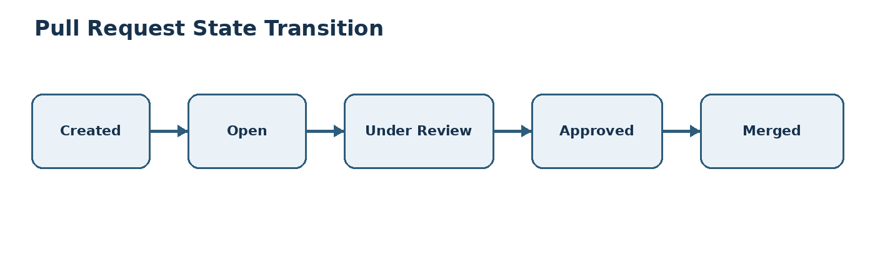
Test Case | Current State | Action | Expected State
ST01 | Created | Submit PR | Open
ST02 | Open | Maintainer reviews | Under Review
ST03 | Under Review | Approval received | Approved
ST04 | Approved | Merge PR | Merged
ST05 | Open | PR rejected | Closed

12. Contribution Dashboard
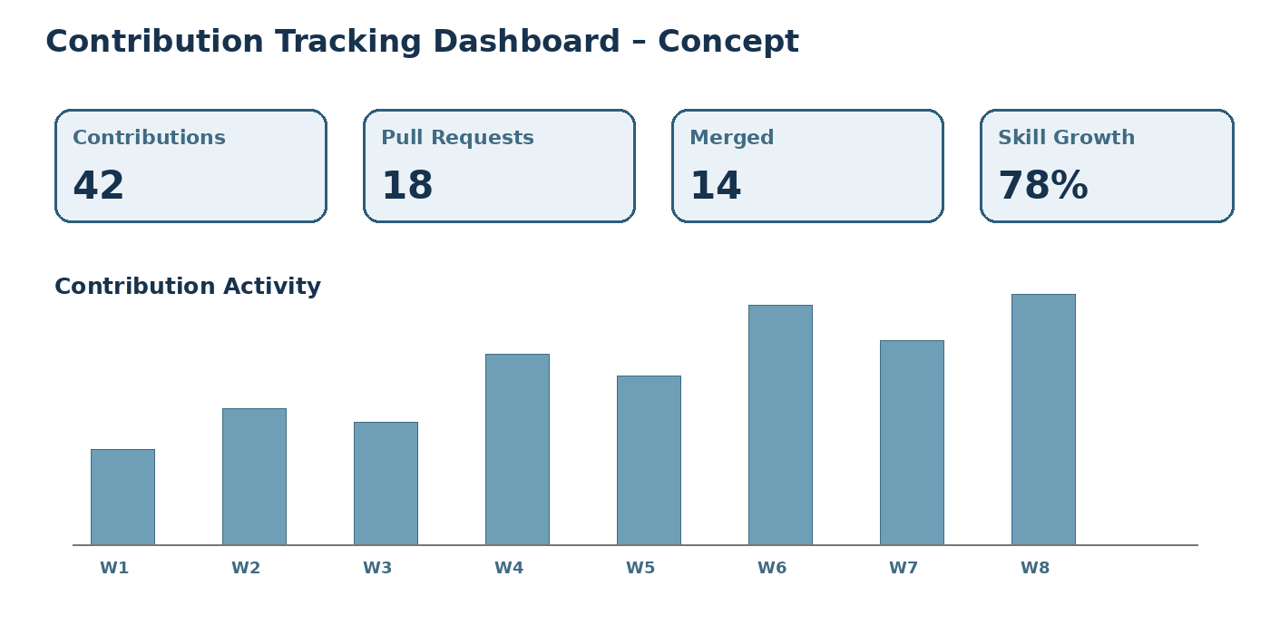
The dashboard concept represents contribution count, pull requests, merged work, skill growth, and weekly contribution activity.

13. Recommendation Decision Flow
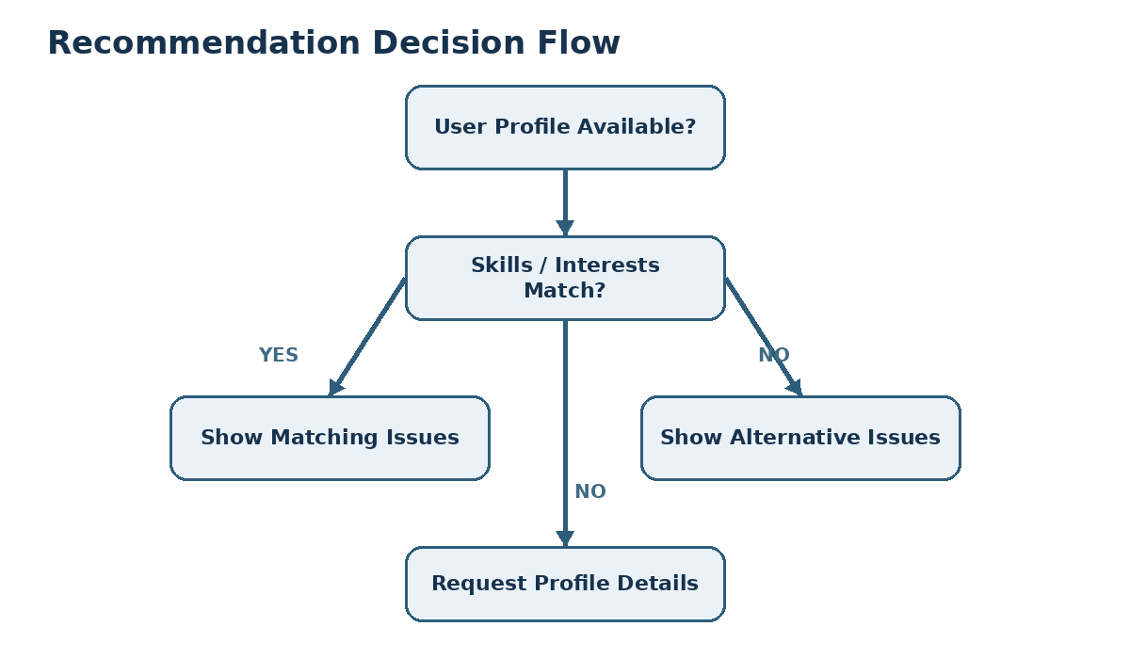
The decision flow ensures that recommendations are generated only when profile information is available and suitable skill/interest matches are found.

14. Traceability Matrix
Requirement | Mapped Test Cases
FR1 – Profile Management | TC01, TC02
FR2 – Skills | TC03, TC04
FR3 – Recommendations | TC05, TC06
FR4 – GitHub API | TC09, TC10
FR5 – Issue Labels | TC07, TC08
FR6 – Contribution Tracking | TC11, TC12, TC13
FR7 – Progress Tracking | TC15
FR8 – Difficulty Scoring | TC14
FR9 – Skill Dashboard | TC15
FR10 – Notifications | TC16
FR11 – Portfolio | TC17
FR12 – Community Insights | TC18
Invalid Input Handling | TC19
Large Data Handling | TC20

15. Test Coverage Summary
Functional requirements | Covered
Non-functional requirements | Covered
Normal conditions | Covered
Boundary conditions | Covered
Invalid conditions | Covered
Exceptional conditions | Covered
Equivalence Partitioning | Applied
Boundary Value Analysis | Applied
Decision Table Testing | Applied
State Transition Testing | Applied
Requirement traceability | Applied

16. Test Result / Conclusion
The test cases designed cover the major functional and non-functional requirements of the Open-Source Contribution Tracker and Recommendation System for Beginner Developers. Normal, boundary, invalid, and exceptional conditions are included. Equivalence Partitioning, Boundary Value Analysis, Decision Table Testing, and State Transition Testing are applied to improve test coverage. The traceability matrix connects requirements with test cases and supports systematic verification of the proposed system.

